PL3 Assignment 4

Team members:

1. 2018BTECS00019 Sarthak Patil
2. 2018BTECS00067 Parth Navale
3. 2018BTECS00068 Sahil Reddy

Problem statement 1

Q 1. Installation of Xampp server

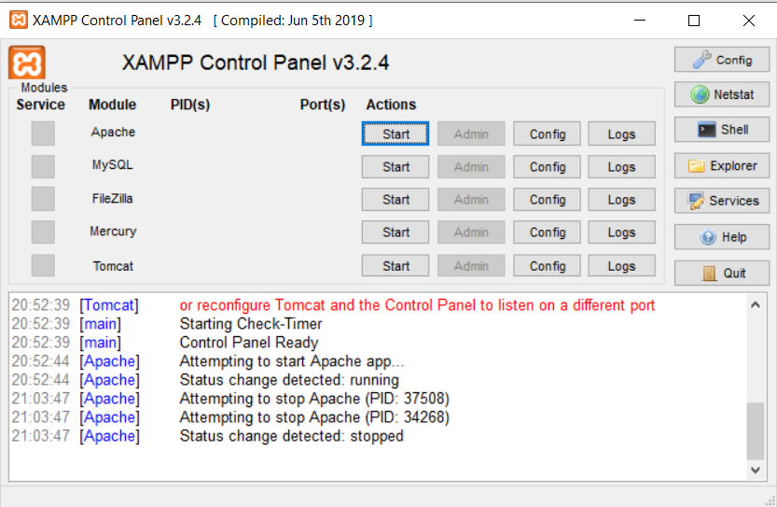

Q 2. Locating and studying configuration files

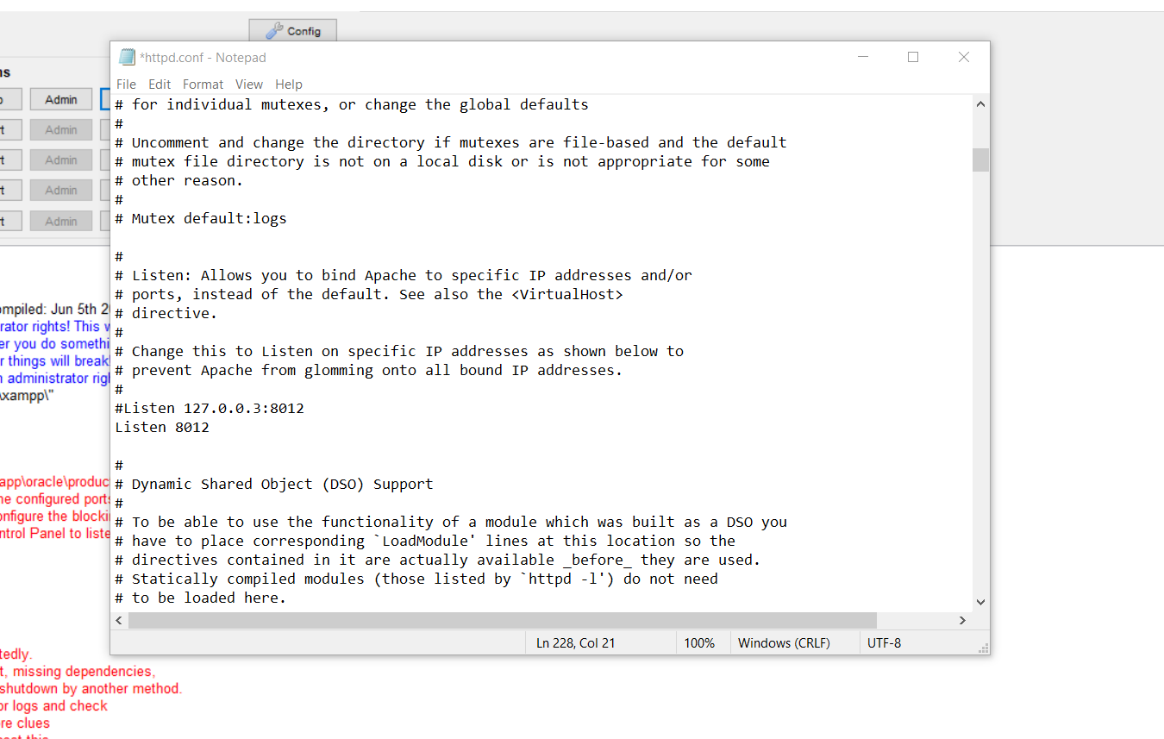

Q 3. Changing the default port number and restarting the server

XAMPP control panel:



Apache default config setting:

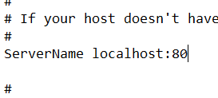

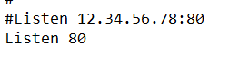

Apache server after clicking start:

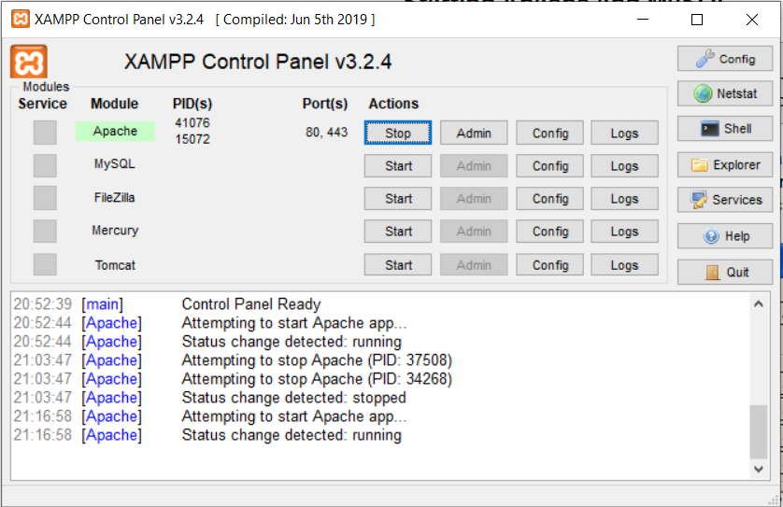

Checking at <http://localhost> on the browser:

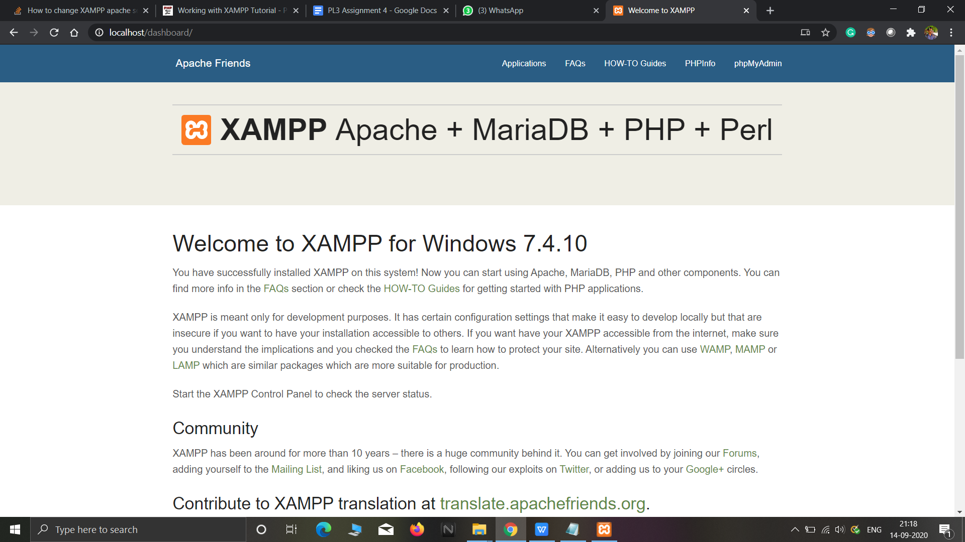

Now changing default port 80 to 8012:



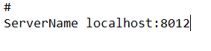

Now starting Apache server on port 8012:

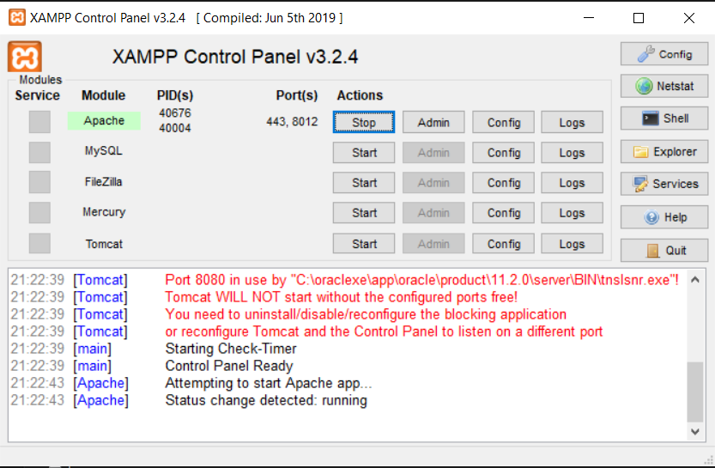

Checking at <http://localhost:8012> on the browser:

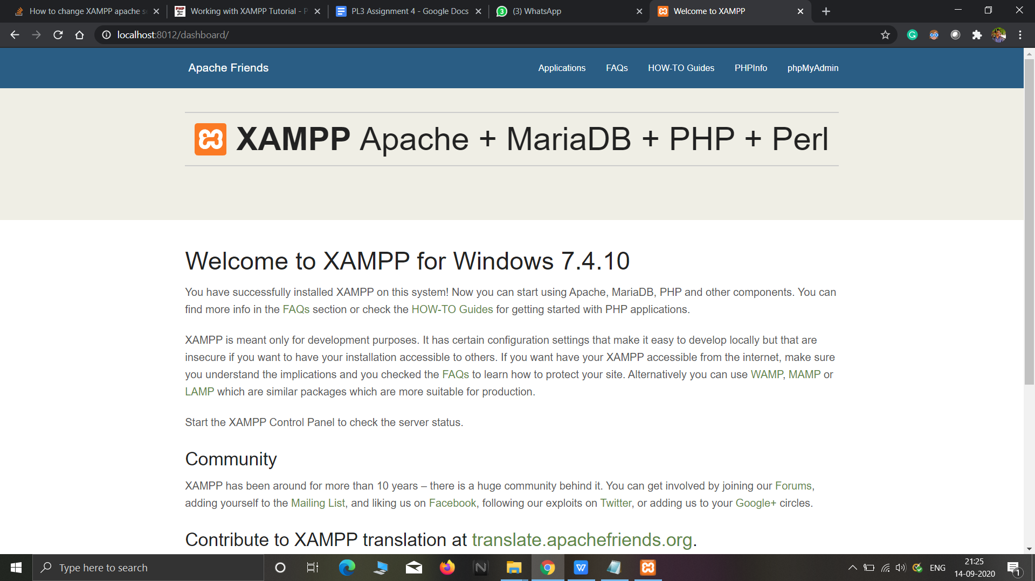

Q4.

1. Changing the default IP address and restarting server

2. Accessing server in the network from another device here Mobile

1.Get the ip address of the network to which laptop is connected.We get this by ipconifg command in command prompt.

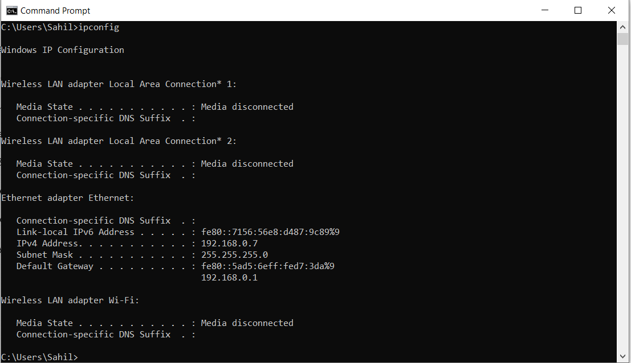

2.In order to change default ip address and port no of the server to other calid ip address and port no:

Apache default config setting:





Now changing default port 80 to 8012:





We have successfully changed the port no now we follow the same steps to change ip address:

We change the ip address to 127.0.0.3



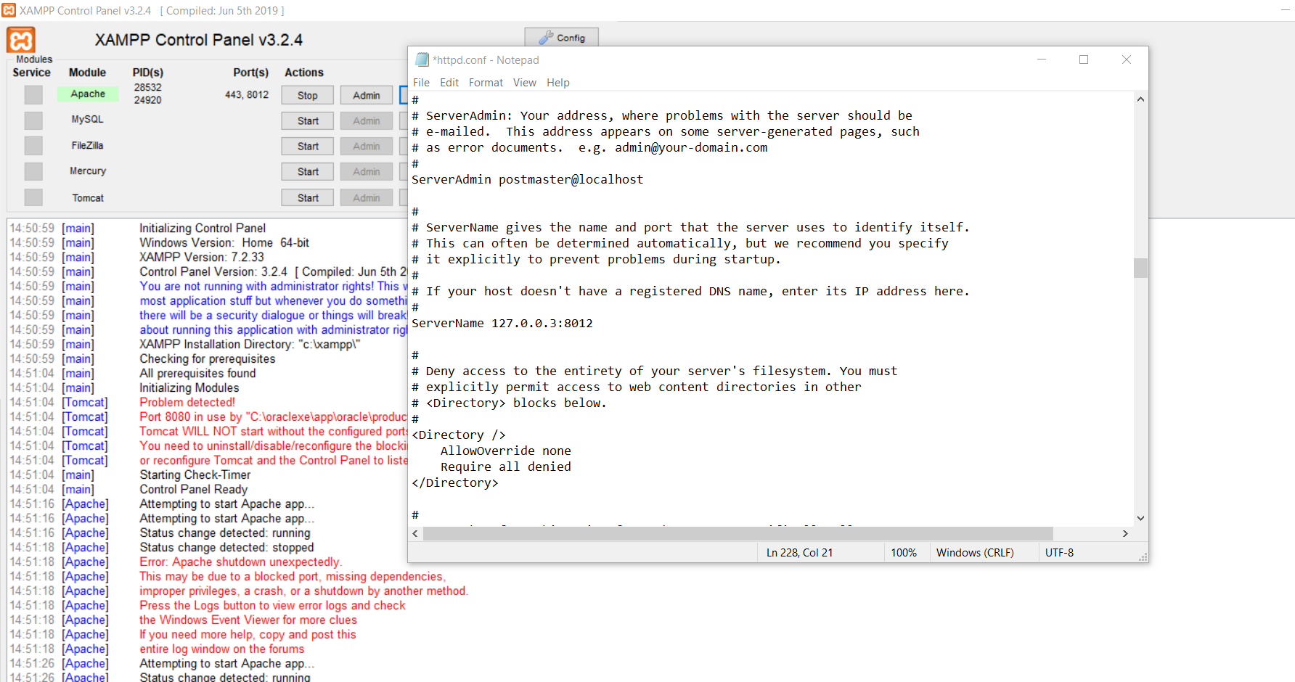

Now we will access the server through newly assigned port no and ip address:

But before that we need to off the antivirus and firewall:

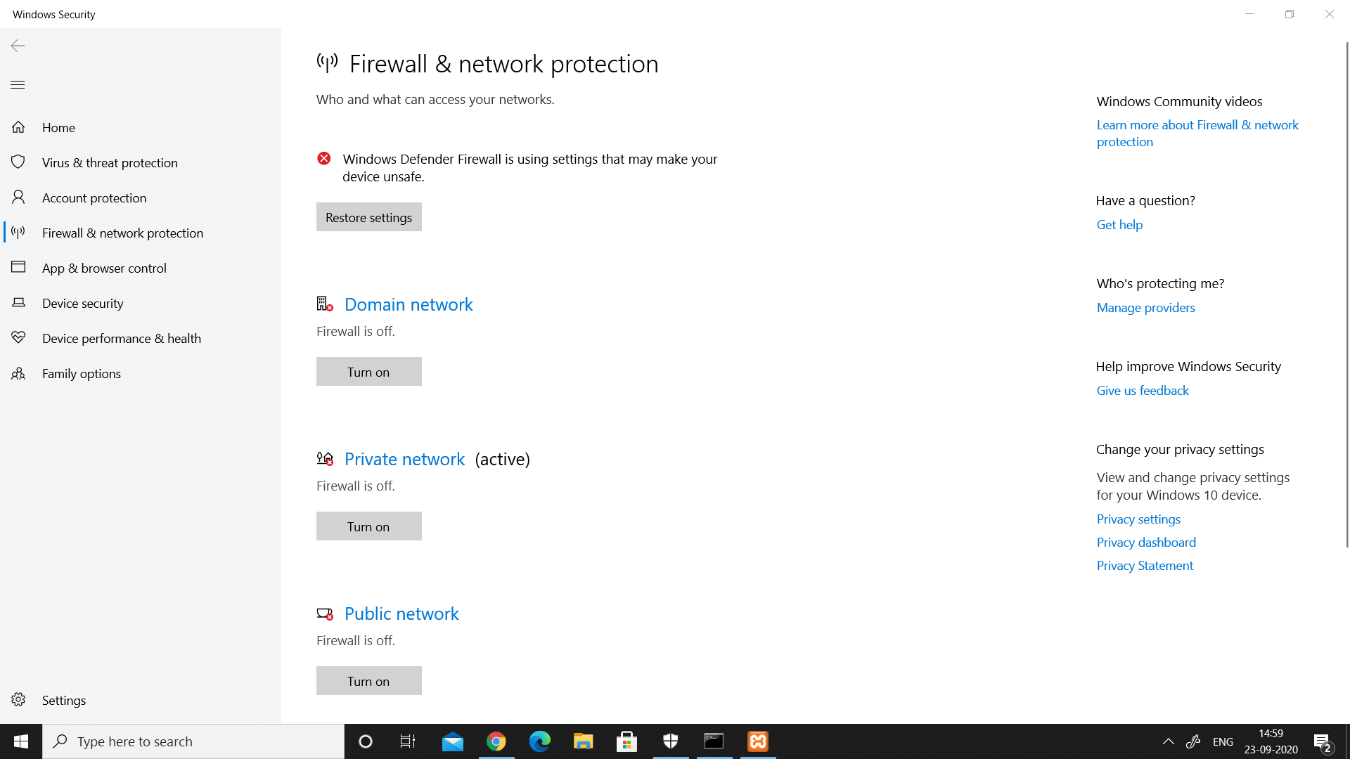

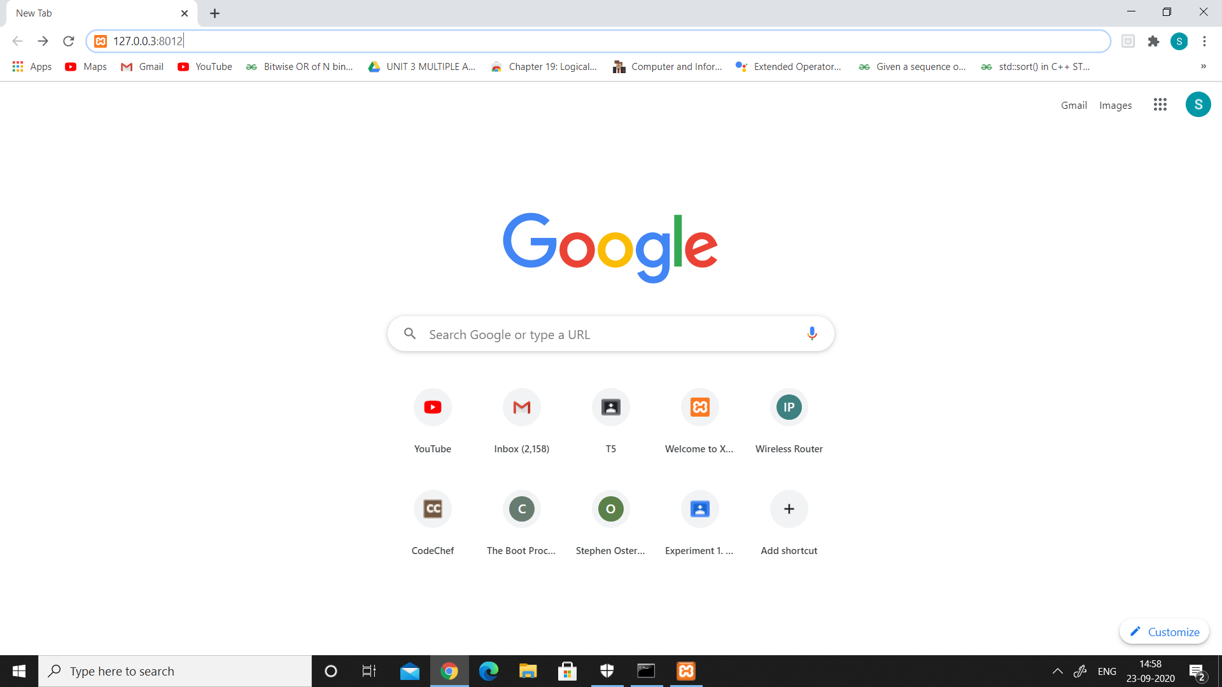

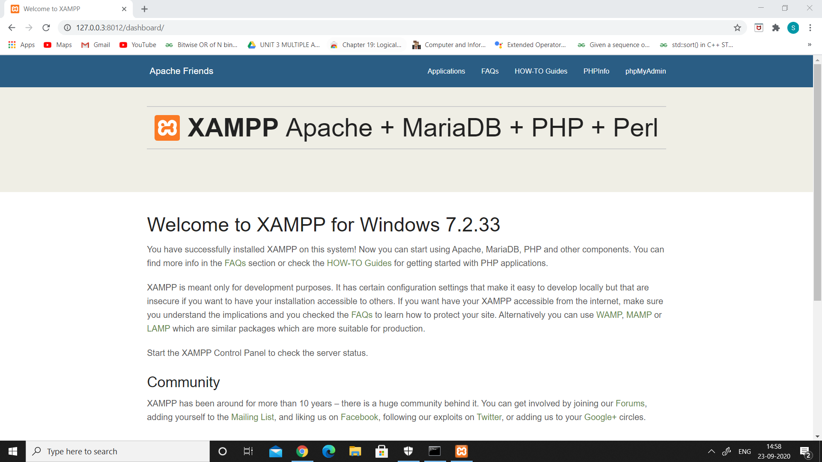

Accessing it from mobile:

Put the ip address 198.168.0.7:8012 in mobile:

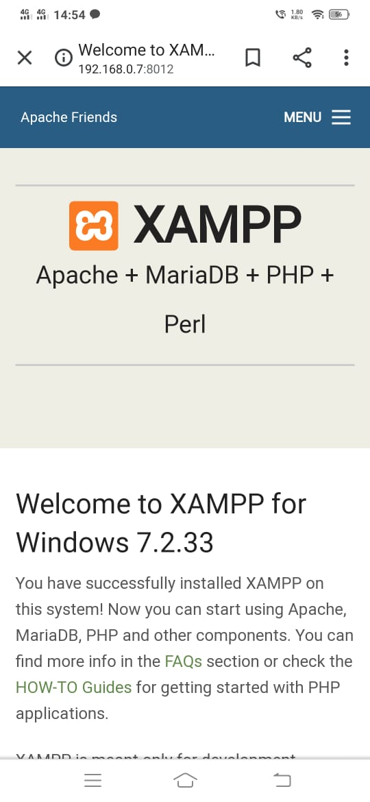

Member contributions:

2018BTECS00019:-

Changing the default port number to another valid port number and rerunning the server on the newly assigned port number

2018BTECS00068:-

Change the default IP address (localhost) and port number of the server in the configuration file to any other valid IP address and port number. Re-run the server and access it in a network from another machine

2018BTECS00067:

Installed the Xampp server from the command line removed the previous version of apache and PHP and

Hosted a site on it